CPE301 – SPRING 2019

Design Assignment 6

Student Name: Victor Martinez

Student #: 5003131674

Student Email: [martiv6@unlv.nevada.edu](mailto:martiv6@unlv.nevada.edu)

Primary Github address: https://github.com/martiv6

Directory: https://github.com/martiv6/submissions_da/tree/master/DesignAssignment/DA6

Submit the following for all Labs:

1. In the document, for each task submit the modified or included code (only) with highlights and justifications of the modifications. Also, include the comments.
2. Use the previously create a Github repository with a random name (no CPE/301, Lastname, Firstname). Place all labs under the root folder ESD301/DA, sub-folder named LABXX, with one document and one video link file for each lab, place modified asm/c files named as LabXX-TYY.asm/c.
3. If multiple asm/c files or other libraries are used, create a folder LabXX-TYY and place these files inside the folder.
4. The folder should have a) Word document (see template), b) source code file(s) and other include files, c) text file with youtube video links (see template).

1. **COMPONENTS LIST AND CONNECTION BLOCK DIAGRAM w/ PINS**

MPU 6050

328P

Mini

POWERSUPPLY

1. **INITIAL/MODIFIED/DEVELOPED CODE OF TASK 1/A**

/*

* DA6.c

*

* Created: 4/30/2019 8:36:48 PM

* Author : martiv6

*/

#define F_CPU 16000000UL // Define CPU clock Frequency

#include <avr/io.h> // Include AVR std. library file

#include <util/delay.h> // Include delay header file

#include <inttypes.h> // Include integer type header file

#include <stdlib.h> // Include standard library file

#include <stdio.h> // Include standard library file

#include "MPU6050_res_define.h" // Include MPU6050 register define file

#include "I2C_Master_H_file.h" // Include I2C Master header file

#include "USART_RS232_H_file.h" // Include USART header file

float Acc_x,Acc_y,Acc_z,Temperature,Gyro_x,Gyro_y,Gyro_z; //the values which we will hold the acceleration and position

int main()

{

char buffer[20], float_[10];

float Xa,Ya,Za,t;

float Xg=0,Yg=0,Zg=0;

I2C_Init(); // Initialize I2C

MPU6050_Init(); // Initialize MPU6050

USART_Init(9600); // Initialize USART with 9600 baud rate

while(1)

{

Read_RawValue();

Xa = Acc_x/16384.0; // Divide raw value by sensitivity scale factor to get real values

Ya = Acc_y/16384.0;

Za = Acc_z/16384.0;

Xg = Gyro_x/16.4;

Yg = Gyro_y/16.4;

Zg = Gyro_z/16.4;

*dtostrf*( Xa, 3, 2, float_ ); // Take values in buffer to send all parameters over USART

*sprintf*(buffer," Ax = %s g\t",float_);

USART_SendString(buffer);

*dtostrf*( Ya, 3, 2, float_ );

*sprintf*(buffer," Ay = %s g\t",float_);

USART_SendString(buffer);

*dtostrf*( Za, 3, 2, float_ );

*sprintf*(buffer," Az = %s g\t",float_);

USART_SendString(buffer);

*dtostrf*( Xg, 3, 2, float_ );

*sprintf*(buffer," Gx = %s%c/s\t",float_,0xF8);

USART_SendString(buffer);

*dtostrf*( Yg, 3, 2, float_ );

*sprintf*(buffer," Gy = %s%c/s\t",float_,0xF8);

USART_SendString(buffer);

*dtostrf*( Zg, 3, 2, float_ );

*sprintf*(buffer," Gz = %s%c/s\r\n",float_,0xF8);

USART_SendString(buffer);

*_delay_ms*(1000);

}

}

void MPU6050_Init() // Gyro initialization function

{

*_delay_ms*(150); // Power up time >100ms

I2C_Start_Wait(0xD0); // Start with device write address

I2C_Write(SMPLRT_DIV); // Write to sample rate register

I2C_Write(0x07); // 1KHz sample rate

I2C_Stop();

I2C_Start_Wait(0xD0);

I2C_Write(PWR_MGMT_1); // Write to power management register

I2C_Write(0x01); // X axis gyroscope reference frequency

I2C_Stop();

I2C_Start_Wait(0xD0);

I2C_Write(CONFIG); // Write to Configuration register

I2C_Write(0x00); // Fs = 8KHz

I2C_Stop();

I2C_Start_Wait(0xD0);

I2C_Write(GYRO_CONFIG); // Write to Gyro configuration register

I2C_Write(0x18); // Full scale range +/- 2000 degree/C

I2C_Stop();

I2C_Start_Wait(0xD0);

I2C_Write(INT_ENABLE); // Write to interrupt enable register

I2C_Write(0x01);

I2C_Stop();

}

void MPU_Start_Loc()

{

I2C_Start_Wait(0xD0); // I2C start with device write address

I2C_Write(ACCEL_XOUT_H); // Write start location address from where to read

I2C_Repeated_Start(0xD1); // I2C start with device read address

}

void Read_RawValue() // Read Gyro values

{

MPU_Start_Loc();

Acc_x = (((int)I2C_Read_Ack()<<8) | (int)I2C_Read_Ack());

Acc_y = (((int)I2C_Read_Ack()<<8) | (int)I2C_Read_Ack());

Acc_z = (((int)I2C_Read_Ack()<<8) | (int)I2C_Read_Ack());

Gyro_x = (((int)I2C_Read_Ack()<<8) | (int)I2C_Read_Ack());

Gyro_y = (((int)I2C_Read_Ack()<<8) | (int)I2C_Read_Ack());

Gyro_z = (((int)I2C_Read_Ack()<<8) | (int)I2C_Read_Nack());

I2C_Stop();

}

1. **SCHEMATICS**

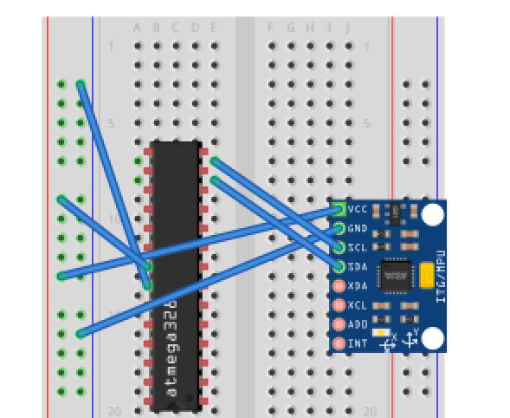

1. **SCREENSHOT OF EACH DEMO (ATMEL SETUP)**

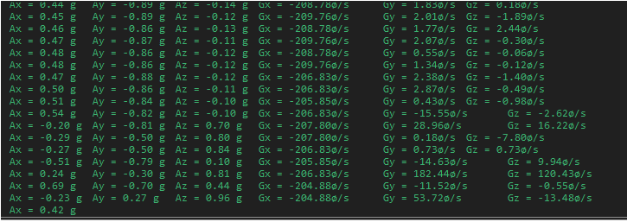

1. **SCREENSHOT OF EACH DEMO (BOARD SETUP)**

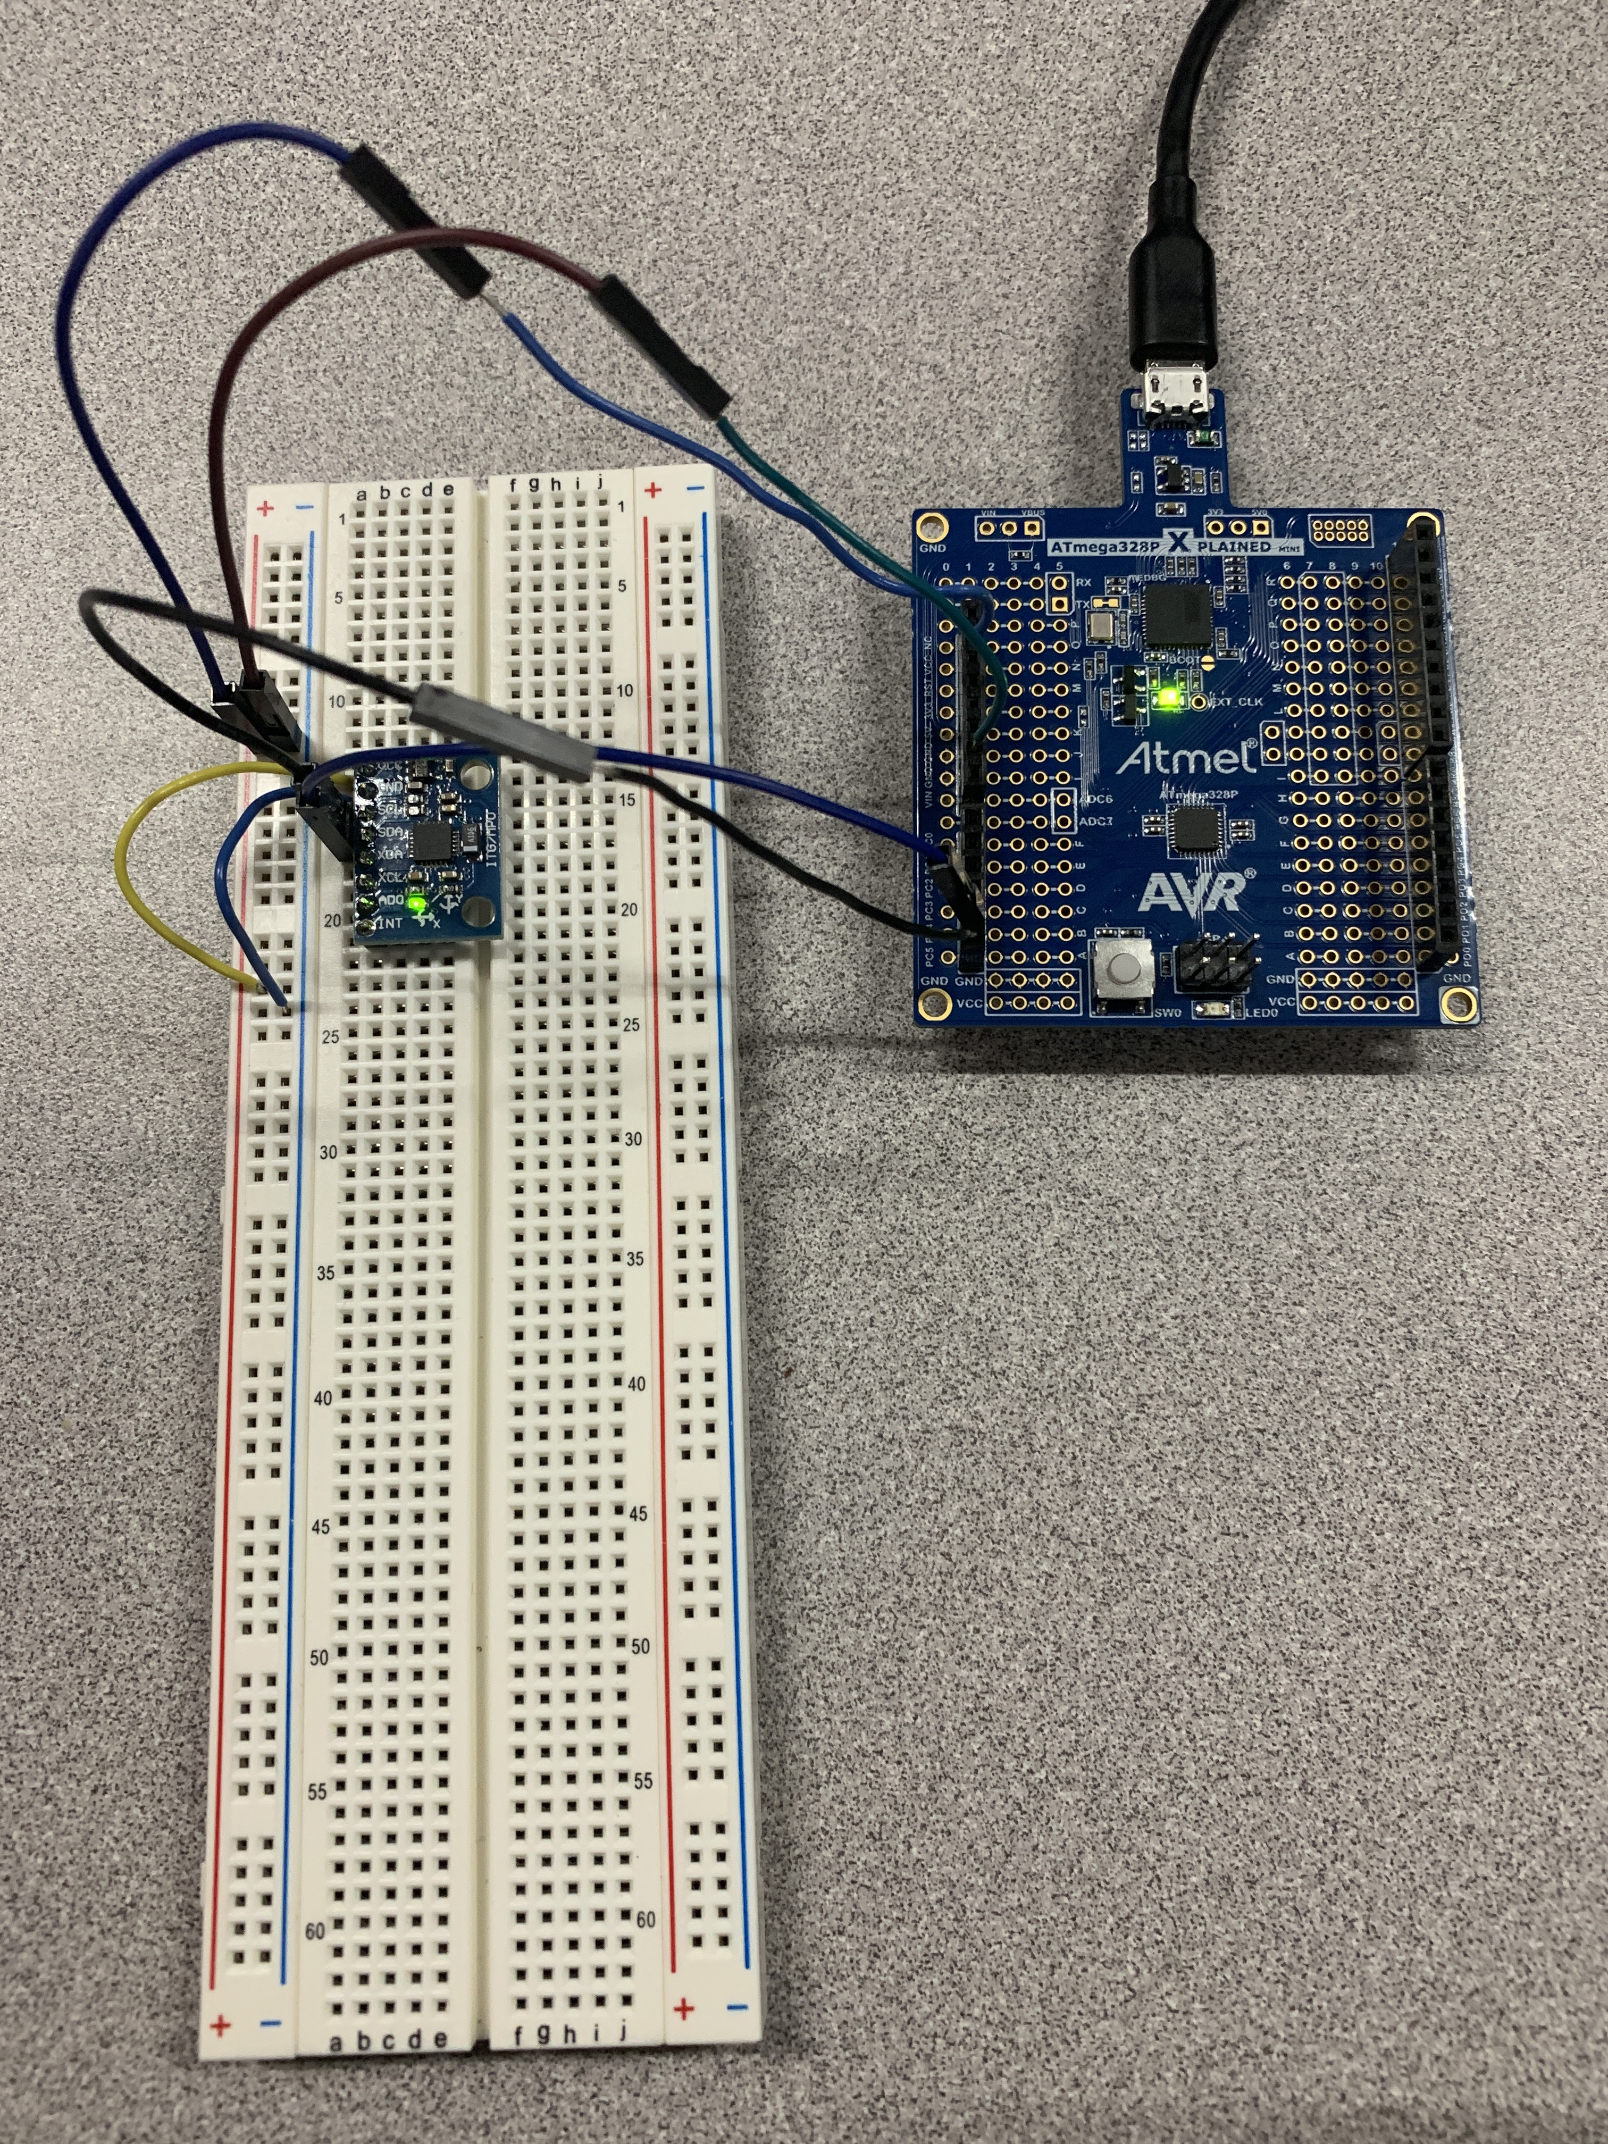

1. **VIDEO LINKS OF EACH DEMO**

<https://youtu.be/fhPKMSf5fSg>

1. **GITHUB LINK OF THIS DA**

<https://github.com/martiv6/submissions_da/tree/master/DesignAssignment/DA6>

**Student Academic Misconduct Policy**

<http://studentconduct.unlv.edu/misconduct/policy.html>

“This assignment submission is my own, original work”.

VICTOR MARTINEZ